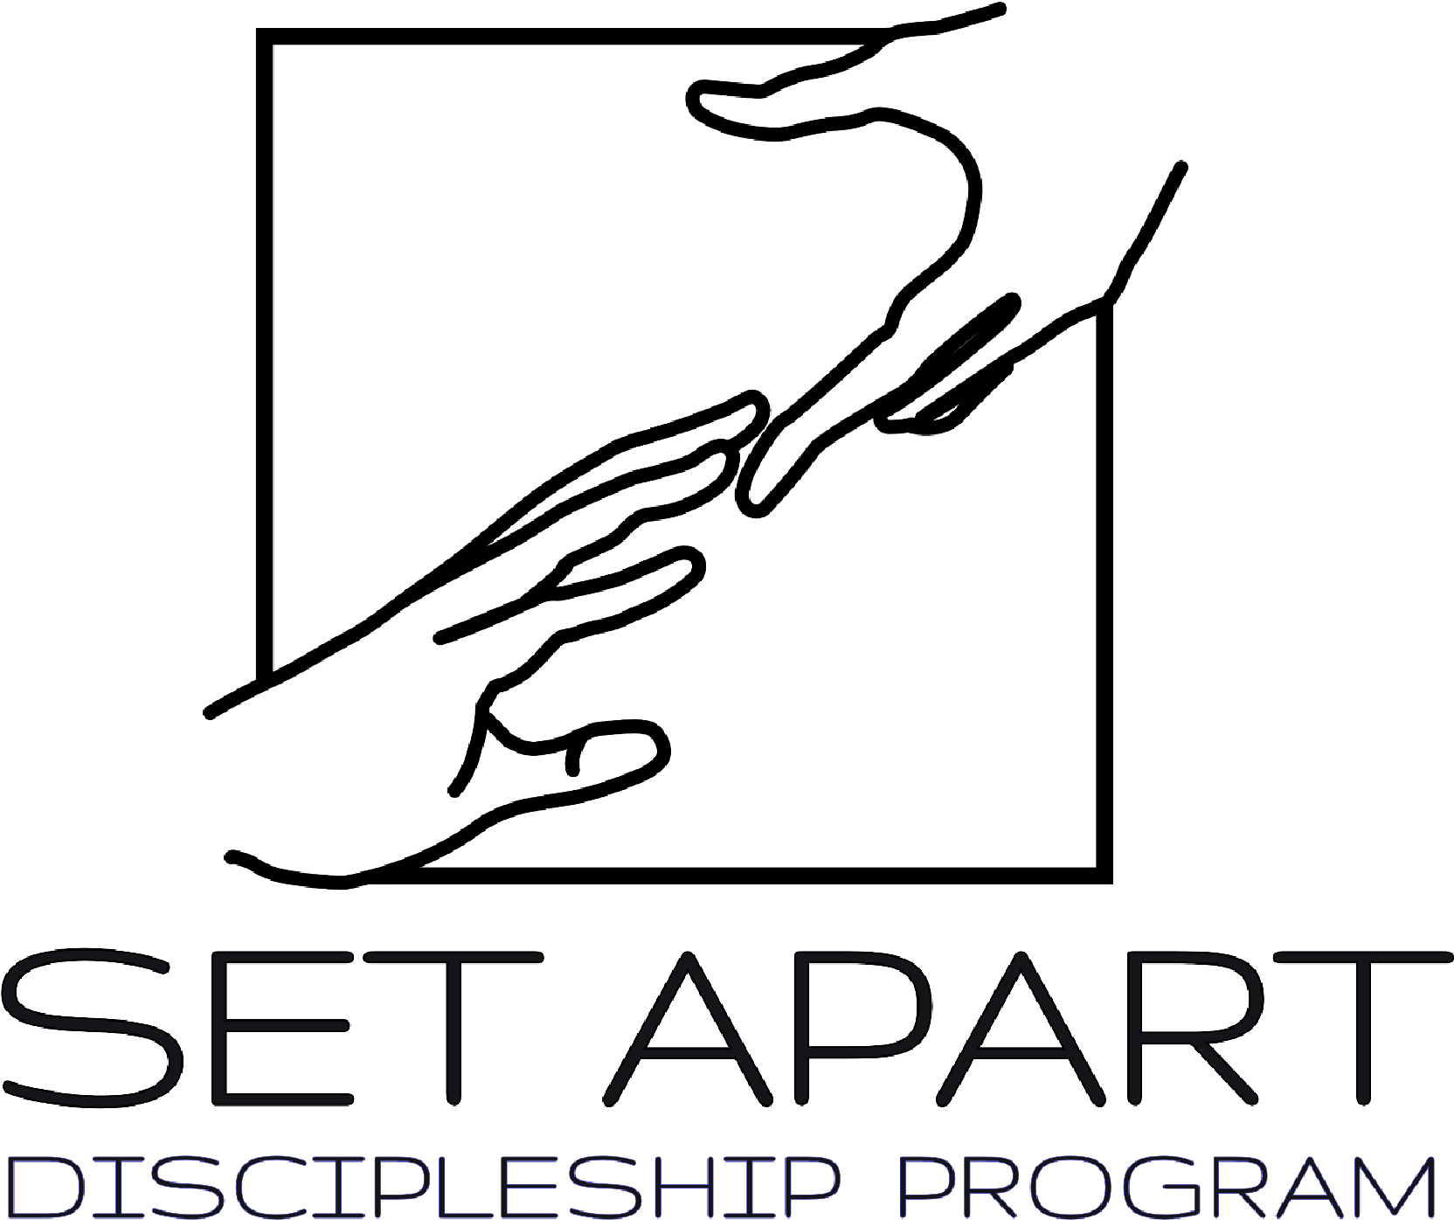

Year One Application

Set Apart Nine-Month
Discipleship Program
Runs September 13th - June 6th

Set Apart is a 9-month gap year program for young adults between the ages of 18-30. The focus is on igniting your faith and equipping you to impact the world. Students grow in Discipleship, Leadership Training, and Missions. They will learn from passionate instructors and gain in practical, hands-on, leadership skills through serving within the ministries of Destiny Church. Learning and growing in the image and likeness of Jesus, praying for people, sharing the gospel through evangelism, preparing sermons, and intentionally pouring into the next generation. Set Apart’s desire is to prepare students to be relevant leaders in their communities, churches and on the mission field.

The heart of the program is call out everything God has placed in you and to take all the ceilings off your spiritual growth.

We are excited that you are feeling called to grow deeper with the Lord and look forward to receiving your application. We prayerfully consider and only accept a set amount of disciples annually.

FOUR KEY AREAS OF SET APART

1. DISCIPLESHIP
Deepen your faith by interacting regularly with gifted teachers, engaging in small groups, and meeting for discipleship with staff members and powerful men and women of God.

Discipleship happens best when it’s done within the context of shared experiences, which is why nearly everything we do is done in the community!

We’ll play together, pray together, and process the many experiences we share in an atmosphere of mutual support and care.

Throughout your Set Apart experience, you’ll participate in a small group with other students who are in the program. This is the place where your relationships deepen, accountability happens, and where you’ll be personally challenged to live out the things God is showing you. You’ll also receive one-on-one mentoring from a staff member.

An essential part of the discipleship process you will experience in Set Apart comes through dynamic teachings. On an almost daily basis, you’ll receive biblical teaching from pastors, guest speakers, missionaries, and business professionals who have a passion for Christ. These speakers will not only encourage and challenge you in your relationship with God but also in your relationships with those around you. You’ll grow in your understanding of who God is, who you are in Christ and your role in the expansion of His Kingdom.

Some (but not all!) of the topics covered during the Set Apart school year include:
- In Christ Image Training (ICIT online courses)
- A Lifestyle of Worship and Prayer
- Spiritual Disciplines
- Identity in Christ/ Spiritual gifts/ Love languages
- Youth and Children’s Ministry
- Finance and Budgeting
- Book Studies (chosen for each specific year)
- Spiritual Warfare
- The Father Heart of God
- Forgiveness and Reconciliation
- Missions & Evangelism
- Biblical Leadership
- Relationships

- LEADERSHIP
The best leaders are the greatest servants. Your willingness to serve others will dictate your ability to lead them well. Acts of service and following anointed leadership will prepare you to lead by example.

- COMMUNITY
Community is a big deal in Set Apart - you could say it’s one of our foundational values! There is a strong focus on relational development within the Set Apart community. You’ll develop relationships with other students and staff members.

- MISSIONS & EVANGELISM
Make an impact in lives of others by participating in a Missions trip. Every student will experience a mission trip during their time in Set Apart whether overseas or a local mission. Each student must be able to and willing to travel abroad.

Our goal throughout the year is to spread the gospel through outreaches and evangelism. We are called to be disciples and make disciples. Our goal is not only to go overseas on a mission trip but to serve our local community too through outreaches.

FAQs

Who is Set Apart designed for?
Set Apart is designed for high school graduates ages 18-30 who desire a season committed to growing in their relationship with God. Through discipleship, leadership training, and missions, you will be challenged and encouraged to go deep and live life with God.

We want you to discover your unique passions, giftings and calling. We want to see God equip you to pursue everything He has created you for and
prepared beforehand for you to walk in. This comes with a spirit of excellence and a passion for the things of the Spirit.

Some of our students enter the program knowing where they want to serve and feel called to full-time ministry. Set Apart provides a launching pad for their dreams. We also have students who are unsure about their future and come with an open heart. Set Apart allows them to draw close to God as they seek His plan for their life.

How is Set Apart different than college?
This is a season that students intentionally set aside to focus on walking with God and learning more about Him. You will gain freedom and break the strongholds off your life. As you seek God, you will see your strengths revealed and developed. Set Apart combines classroom time, group activities, small groups, and internships. You will apply what you are learning in practical ways. The goal of Set Apart is not to obtain a grade or a degree but to focus on personal application and growth. A season in Set Apart will transform your heart and life.

When should I apply? What is the application process like?
We begin accepting applications in the spring and will take applications until mid-August. After August, acceptance to Set Apart is conditional based on availability. We recommend applying by spring or early summer because spots fill up and it’s helpful to get a jump-start on support raising.

What are Set Apart’s breaks or holidays?
Thanksgiving Weekend (starting Wednesday, Nov 26-29th)
Christmas Break: December 22nd- January 2nd
Spring Break: March 19th - March 27th

How much does it cost to attend Set Apart?
The full price for Set Apart is $1750.00.
A $250.00 deposit is due upon acceptance into the program. This fee is non-refundable. The remaining tuition ($1500.00) needs to be paid in full prior to the start of the program.

What are the Student Requirements?

- Must have a vehicle and car insurance.
- Must have a part-time job.
- A properly signed Set Apart Application, Code of Conduct Agreement, Liability Release, and Background Check.
- Must uphold and follow the Core Values in the Set Apart Program.
- Must memorize scripture and complete Word Study weekly.
- Must have a protected guaranteed quality prayer time daily.
- Must have the heart of a servant.
- Must maintain a no dating policy for the duration of the nine months of Set Apart.
- Must relocate to a host family if fitting.
- Must serve under the ministry of Destiny Church.
- Must commit to graduate from the Set Apart Program. (Duration of 9 months)
- Must not have any outstanding financial obligations.
- Must have a personal Bible and journal.
- Must adhere to the class schedule and be aware of the allowed time off for holidays.
- Must be between the ages of 18-30.
- Tuition of $1750 due upon admission and is non-refundable.
- Students may be randomly drug tested.
- Must have a personal iPad, tablet or laptop computer.

EXPECTATIONS
Be on time
5 Minute Grace Period for all classes, activities, events or ministry commitments. If the arrival time is more than 5 minutes late, it needs to be communicated to leadership prior to arrival to church or activity.
Stay Committed
All homework, studies, and assignments are expected to be completed in a timely manner. All areas of service are expected to be fulfilled when at all possible, with the right attitude and heart. If there is an issue with arrival or conflict with schedule, please communicate with the department head or Set Apart Leadership as soon as possible.
Be respectful
All staff, church membership, and fellow students are expected to receive respectful attitudes, loving responses and to experience Christlikeness while encountering you.

DEMERIT & STRIKE POLICY
- Warning
- Sit Down with Leadership
- 1 Strike
- 3 Strikes - Sent home and “Benched” from ministry aspects
- 5 Strikes - Suspension
- 10 Strikes - Removal from the Program
* All correction and discipline are subject to a case-by-case basis and might result in multiple strikes or immediate removal from the program

APPLICATION PROCESS:

Once the required forms are submitted to the Set Apart admission office they will be reviewed by staff. After your forms have been reviewed you will be contacted for a brief interview to get to know you and determine if the program seems to be a fit for you.

After your interview and prayerful consideration, you will be notified if you have been accepted into the program via email or phone call. All Applications can be emailed, mailed, or dropped off.

Email complete application to:
zack@destinynaples.com

Drop-off or Mail:
10610 Immokalee Rd, Naples FL, 34120

Set Apart Application

Personal Information:
Full Name___________________________________________________ Present Address______________________________________________
City___________________ State__________ Zip__________________
Home Phone Number_________________ Cell Phone _______________
E-Mail Address__________________________________________
Facebook Yes/No
Year of High School Graduation or equivalent________________________

Family Background:
Name of Father or Guardian_________________ Phone ______________
Address____________________________________________________
City___________________ State__________________ Zip___________
Accepted Christ? Yes No
Occupation_____________________________

Name of Mother or Guardian_________________ Phone ______________
Address____________________________________________________
City___________________ State__________________ Zip___________
Accepted Christ? Yes No
Occupation_____________________________

Medical Background:
How would you describe your health? Excellent Good Fair Poor
List any Allergies: _____________________________________________
List any physical limitations: _____________________________________
List any prescription medications you are currently using:
___________________________________________________________
Have you ever used illegal drugs? Yes No
If Yes, Date of last use: ________________ Have you ever smoked tobacco? Yes No
If Yes, Date of last use: ________________ Have you ever drunk alcohol? Yes No
If Yes, Date of last use: ________________
Have you ever had any addictions? Yes No
Explain: ____________________________________________________
Do you have health insurance? Yes No
Have you been convicted of any Felonies? Yes No
If Yes, please explain: __________________________________________
Have you ever been affiliated with Occult? Yes No
If Yes, please explain___________________________________________

References (Name, Relation, and Phone Number):
- _________________________________________________________
- _________________________________________________________
- _________________________________________________________

Church Background:
Name of home church__________________________________________
Denomination________________________________________________
Address____________________________________________________
City_____________________ State_________ Zip__________________
Phone Number_______________________________________________
Name of Senior Pastor_________________________________________
Name of Youth Pastor__________________________________________ How long have you attended this church? __________________________ List the different ministries you are presently involved with:
When did you accept Christ _____________________________________
Where? ____________________________________________________ Have you ever been baptized in water? Yes No Have you ever had an Act 2:4 experience?
- “And they were all filled with the Holy Spirit and began to speak with other tongues, as the Spirit gave them utterance.” Yes No
How many times a week do you attend a church function? ________________ How do your parents/guardians feel about you coming to Set Apart?
___________________________________________________________
___________________________________________________________
Do you have any family conflicts that would affect your position in Set Apart?
Yes No
Are you currently enrolled/planning on enrolling in any other kind of School?
Yes No
If yes, please describe:_________________________________________

Questionnaire:
- Why do you want to be in Set Apart at Destiny Church Naples?
___________________________________________________________
- Describe a time in your life when you really needed the Lord (other than salvation)?___________________________________________________
_______________________________________________________________
- Are you currently in a relationship? Yes No
- If No, when was your last relationship: ___________________________
- What do you plan to do after your internship?
___________________________________________________________
___________________________________________________________
- What areas of your life do you need change or growth in?
___________________________________________________________
___________________________________________________________
___________________________________________________________
___________________________________________________________
___________________________________________________________
- Who has influenced your life the most?
___________________________________________________________
___________________________________________________________
___________________________________________________________
___________________________________________________________
___________________________________________________________
- With a 10 being the highest, how would you rate your spiritual life now? Why?
___________________________________________________________
___________________________________________________________
___________________________________________________________
___________________________________________________________
___________________________________________________________
- What are your greatest character strengths? What are your greatest character weaknesses?
___________________________________________________________
___________________________________________________________
___________________________________________________________
___________________________________________________________
___________________________________________________________ ___________________________________________________________

- Describe your relationship with your parents and siblings and Church
Leadership.__________________________________________________ ___________________________________________________________
___________________________________________________________
___________________________________________________________
___________________________________________________________
___________________________________________________________
- List extracurricular activities you have been involved in. (sports, music, debate, etc)
___________________________________________________________
___________________________________________________________
___________________________________________________________
___________________________________________________________ ___________________________________________________________

- Please (1) circle an area of ministry that you would like to intern with. (2) Underline a second choice.
  - High School Ministry • Children’s Ministry
  - Young Adult Ministry
  - Middle School Ministry
  - Media Ministry
  - Worship Ministry
  - Administration

Make and Model of Car Plate
#__________________________________________________________

- How do you plan on paying for your tuition?
___________________________________________________________
14. How do you plan on meeting your personal expenses while in Set Apart?
___________________________________________________________

Please include the following with your application:

- Your personal testimony on a separate sheet of paper (minimum of 200 words typed)
- A recent photo of yourself (will not be returned)
- What do you expect out of your time in Set Apart this year? (separate sheet, minimum of 100 words typed)
- A copy of your driver's license and vehicle insurance.
- A current Passport. (provide a copy of your passport photo)
- List any debts, loans, and payments that you presently have including the amount due for each. If any of these will be paid off before Set Apart starts, please state.

By signing this application you are agreeing that:
- I have honestly completed this application form
- Answered the questions to the best of my ability.
- I have read and I am willing to abide by all the guidelines stated.

Signature: _______________________________ Date: ______________

Financial Responsibility

- 1. Tuition for the school year September 2026-June 2027 will be $1750.00. A $250.00 deposit is due upon acceptance into the program. This fee is non-refundable. Remaining tuition in the amount of $1,500 should be paid in full prior to the start of the program.

- Students will be responsible to go on 1 mission trip during the school year. Students will raise their own support for this mission trip. Support letters and fundraising will be available to assist students in raising these funds.

- Students will be responsible for all spending money, gas money, and personal care products.

I _________________ hereby understand my financial responsibilities for the duration of Set Apart.

Student Signature: ______________________________

Date: ____________________________

Code of Conduct

- The Set Apart student will not access inappropriate materials on websites,
social media, phones or reading material. Neither shall there be posting of
inappropriate materials on the above or any other media at any time.
- The Set Apart Student will abstain from every appearance of evil, let no
corrupt communication proceed out of their mouth or engage in idle talk.
- The Set Apart Student views themselves as a “Temple of God” and shall
refrain from alcohol, smoking, gambling, ungodly language, substance
abuse or involvement in any inappropriate actions.
- The Set Apart Student is a steward of all that God have given and shall
demonstrate wisdom by recording, handling, and protecting all monies
gathered by fund raisers, offerings, sales of merchandise etc. Students
must honor God in every financial situation.
- The Set Apart Student will study to show themselves approved unto God
a workman that needs not to be ashamed rightly dividing the word of truth.
- The Set Apart Student must not compromise the integrity of Set Apart or
Destiny Church Naples by engaging in any activity that will damage the
reputation of either.
- The Set Apart Student will minister to their specific gender, (male to male
and female to female), unless so directed by the Director of Set Apart or
Pastor present.
- The Set Apart Student will develop an attitude of accountability to the
administration, instructors, and leadership of both Set Apart and Destiny
Church.

Student Signature: ______________________________

Date: ____________________________

Liability Release Form

Sept. 13, 2026 -June 6, 2027
Student Name _______________________________________________
Phone Number _____________ Email Address _____________________
Date of Birth_________________________________________________
Address____________________________________________________
City ______________________ State_________ Zip________________

On this ________________ day of ____________, 2026. I/We

________________________________ intending to be legally bound hereby, the undersigned agrees and does hereby release from liability and to indemnify and hold harmless Destiny Church Naples, Set Apart, and any of its Pastors, employers or agents, volunteer workers representing or related to the church. This release is for any and all liability for personal injuries (including death) and property losses or damage occasioned by, or in connection with any activity or accommodations during the course of involvement. The undersigned further agrees to abide by the rules and regulations promulgated by Destiny Church Naples, Set Apart, and/or affiliate groups and vendors during the course of involvement with the above parties. In the event that he/she is injured and requires the attention of a doctor, I/We consent to any reasonable medical treatment as deemed necessary by a licensed physician. In the event, treatment is required from a physician and/ or hospital personnel designated by the Destiny Church Naples, Set Apart, its Pastors, employees or agents, volunteer workers, I/We agree to hold such person free and harmless of any claims, demands, or suits for damages arising from the giving of such consent. I/We also acknowledge that I/We will be ultimately responsible for the cost of any medical care should the cost of medical care not be reimbursed by the student's health care provider.

___________________________________________ ______________
Student Signature Date

___________________________________________ ______________
Witness Signature Date

___________________________________________ ______________
Witness Signature Date

___________________________________________ ______________
Notary Signature Date

(Mrs. Sandy at the church is a notary so no need to have this notarized elsewhere unless you desire another notary)

